**Ministerul Educației și Cercetării al Republicii Moldova**

**Universitatea Tehnică a Moldovei**

**Facultatea Calculatoare, Informatică şi Microelectronică**

**Departamentul Informatică şi Ingineria Sistemelor**

**RAPORT**

Lucrare de laborator nr.3

la cursul „Analiza si Sinteza Dizpozitivelor Numerice”

**Tema:**„ Sinteza decodificatoarelor şi codificatoarelor”

Varianta 3

A efectuat: **st. gr. TI-214 Buza Cătălin**

A verificat:  **asistent univ. Ursu Adriana**

**Chișinău 2022**

1. Efectuaţi sinteza unui decodificator complet cu trei variabile de intrare.
2. Efectuaţi sinteza unui decodificator binar-zecimal conform variantei din tabelul 4.3 ( la indicaţia profesorului).
3. 3. Efectuaţi sinteza unui codificator binar-zecimal conform variantei din tabelul 4.3 (la indicaţia profesorului).

|  |  |  |
| --- | --- | --- |
| **Nr.var** | **Codul binar-zecimal de Decodificator** | **Codul binar-zecimal de Codificator** |
| 3 | 8 5 (-2) (-4) | 3 3 2 1 |

1.Tabelul de adevăr al Decodificatorului pentru codul binar-zecimal 8 5 (-2) (-4)

|  |  |  |  |  |  |  |  |  |  |  |  |  |  |  |  |
| --- | --- | --- | --- | --- | --- | --- | --- | --- | --- | --- | --- | --- | --- | --- | --- |
|  |  | | | |  | **Funcțiile** | | | | | | | | | |
| 8 | 5 | -2 | -4 |  |  |  |  |  |  |  |  |  |  |  |
| **x1** | **x2** | **x3** | **x4** |  | **y0** | **y1** | **y2** | **y3** | **y4** | **y5** | **y6** | **y7** | **y8** | **y9** |
| **0** | 0 | 0 | 0 | 0 |  | 1 | 0 | 0 | 0 | 0 | 0 | 0 | 0 | 0 | 0 |
| **1** | 0 | 1 | 0 | 1 |  | 0 | 1 | 0 | 0 | 0 | 0 | 0 | 0 | 0 | 0 |
| **2** | 1 | 0 | 1 | 1 |  | 0 | 0 | 1 | 0 | 0 | 0 | 0 | 0 | 0 | 0 |
| **3** | 0 | 1 | 1 | 0 |  | 0 | 0 | 0 | 1 | 0 | 0 | 0 | 0 | 0 | 0 |
| **4** | 1 | 0 | 0 | 1 |  | 0 | 0 | 0 | 0 | 1 | 0 | 0 | 0 | 0 | 0 |
| **5** | 0 | 1 | 0 | 0 |  | 0 | 0 | 0 | 0 | 0 | 1 | 0 | 0 | 0 | 0 |
| **6** | 1 | 0 | 1 | 0 |  | 0 | 0 | 0 | 0 | 0 | 0 | 1 | 0 | 0 | 0 |
| **7** | 1 | 1 | 1 | 1 |  | 0 | 0 | 0 | 0 | 0 | 0 | 0 | 1 | 0 | 0 |
| **8** | 1 | 0 | 0 | 0 |  | 0 | 0 | 0 | 0 | 0 | 0 | 0 | 0 | 1 | 0 |
| **9** | 1 | 1 | 0 | 1 |  | 0 | 0 | 0 | 0 | 0 | 0 | 0 | 0 | 0 | 1 |
|  |  |  |  |  |  |  |  |  |  |  |  |  |  |  |  |
| **10** | 0 | 0 | 0 | 1 |  | * | * | * | * | * | * | * | * | * | * |
| **11** | 0 | 0 | 1 | 0 |  | * | * | * | * | * | * | * | * | * | * |
| **12** | 0 | 0 | 1 | 1 |  | * | * | * | * | * | * | * | * | * | * |
| **13** | 0 | 1 | 1 | 1 |  | * | * | * | * | * | * | * | * | * | * |
| **14** | 1 | 1 | 0 | 0 |  | * | * | * | * | * | * | * | * | * | * |
| **15** | 1 | 1 | 1 | 0 |  | * | * | * | * | * | * | * | * | * | * |

1.1 Tabel de adevăr:

|  |  |  |  |  |  |
| --- | --- | --- | --- | --- | --- |
|  | 8 | 4 | 2 | 1 |  |
|  | x1 | x2 | x3 | x4 | +/- |
| **0** | 0 | 0 | 0 | 0 | + |
| **1** | 0 | 0 | 0 | 1 | - |
| **2** | 0 | 0 | 1 | 0 | - |
| **3** | 0 | 0 | 1 | 1 | - |
| **4** | 0 | 1 | 0 | 0 | + |
| **5** | 0 | 1 | 0 | 1 | + |
| **6** | 0 | 1 | 1 | 0 | + |
| **7** | 0 | 1 | 1 | 1 | - |
| **8** | 1 | 0 | 0 | 0 | + |
| **9** | 1 | 0 | 0 | 1 | + |
| **10** | 1 | 0 | 1 | 0 | + |
| **11** | 1 | 0 | 1 | 1 | + |
| **12** | 1 | 1 | 0 | 0 | - |
| **13** | 1 | 1 | 0 | 1 | + |
| **14** | 1 | 1 | 1 | 0 | - |
| **15** | 1 | 1 | 1 | 1 | + |

1. **Minimizarea functiilor**

|  |  |  |  |  |
| --- | --- | --- | --- | --- |
| **x1 x2**  **x3 x4** | **00** | **01** | **11** | **10** |
| **00** | y0 | y5 | * | y8 |
| **01** | * | y1 | y9 | y4 |
| **11** | * | * | y7 | y2 |
| **10** | * | y3 | * | y6 |

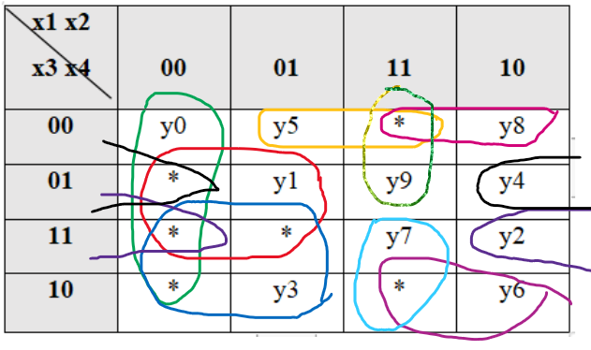

y0= ${\overline{x}}_{1}{\overline{x}}_{2}$ y3= ${\overline{x}}_{1}x_{3}$ y6= $x_{1}x_{3}{\overline{x}}_{4}$ y9= $x_{1}x_{2}{\overline{x}}_{3}$

y1= ${\overline{x}}_{1}x_{4}$ y4= ${\overline{x}}_{2}{\overline{x}}_{3}x_{4}$ y7= $x_{1}x_{2}x_{3}$

y2= ${\overline{x}}_{2}x_{3}x_{4}$ y5= $x_{2}{\overline{x}}_{3}{\overline{x}}_{4}$ y8= $x_{1}{\overline{x}}_{3}{\overline{x}}_{4}$

Baza Și-NU:

$\overline{y0}=\overline{{\overline{x}}_{1}{\overline{x}}_{2}}$ $\overline{y5}$ = $\overline{x_{2}{\overline{x}}_{3}{\overline{x}}_{4}}$

$\overline{y1}$ = $\overline{{\overline{x}}_{1}x_{4} }$ $\overline{y6}$ = $\overline{x_{1}x_{3}{\overline{x}}_{4} }$

$\overline{y2}$ = $\overline{{\overline{x}}_{2}x_{3}x_{4}}$ $\overline{y7}$ = $\overline{x_{1}x_{2}x_{3}}$

$\overline{y3}$ = $\overline{{\overline{x}}_{1}x_{3}}$ $\overline{y8}$ = $\overline{x_{1}{\overline{x}}_{3}{\overline{x}}_{4}}$

$\overline{y4}$ = $\overline{{\overline{x}}_{2}{\overline{x}}_{3}x_{4} }$ $\overline{y9}$ = $\overline{x_{1}x_{2}{\overline{x}}_{3}}$

Schema Decodificatorului în baza Și-Nu

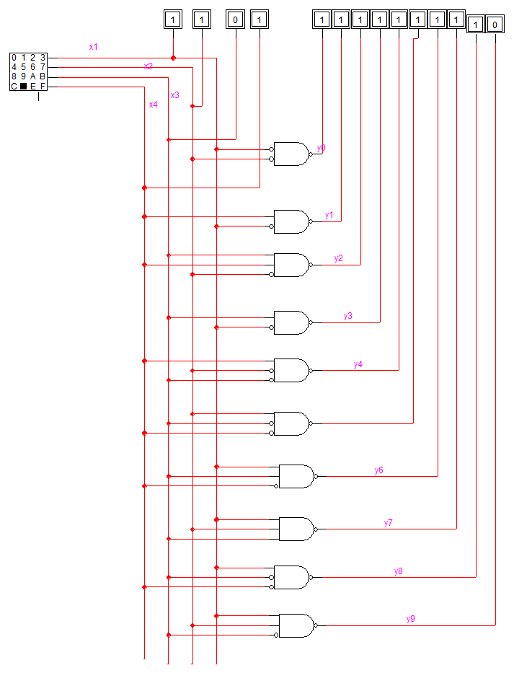

Diagrama de timp:

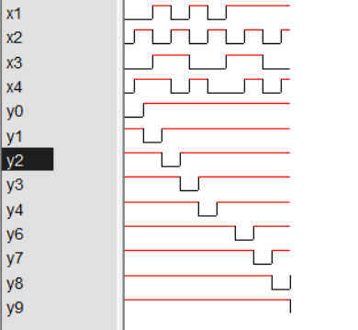

2.Tabelul de adevăr al codificatorului pentru codul binar-zecimal 3 3 2 1

|  |  |  |  |  |  |  |  |  |  |  |  |  |  |  |  |
| --- | --- | --- | --- | --- | --- | --- | --- | --- | --- | --- | --- | --- | --- | --- | --- |
|  | **Intrările** | | | | | | | | | |  | **Ieșirile** | | | |
|  |  |  |  |  |  |  |  |  |  |  |  | 3 | 3 | 2 | 1 |
| **N** | **x0** | **x1** | **x2** | **x3** | **x4** | **x5** | **x6** | **x7** | **x8** | **x9** |  | **f1** | **f2** | **f3** | **f4** |
| 0 | 1 | 0 | 0 | 0 | 0 | 0 | 0 | 0 | 0 | 0 |  | 0 | 0 | 0 | 0 |
| 1 | 0 | 1 | 0 | 0 | 0 | 0 | 0 | 0 | 0 | 0 |  | 0 | 0 | 0 | 1 |
| 2 | 0 | 0 | 1 | 0 | 0 | 0 | 0 | 0 | 0 | 0 |  | 0 | 0 | 1 | 0 |
| 3 | 0 | 0 | 0 | 1 | 0 | 0 | 0 | 0 | 0 | 0 |  | 0 | 1 | 0 | 0 |
| 4 | 0 | 0 | 0 | 0 | 1 | 0 | 0 | 0 | 0 | 0 |  | 0 | 1 | 0 | 1 |
| 5 | 0 | 0 | 0 | 0 | 0 | 1 | 0 | 0 | 0 | 0 |  | 1 | 0 | 1 | 0 |
| 6 | 0 | 0 | 0 | 0 | 0 | 0 | 1 | 0 | 0 | 0 |  | 1 | 1 | 0 | 0 |
| 7 | 0 | 0 | 0 | 0 | 0 | 0 | 0 | 1 | 0 | 0 |  | 1 | 1 | 0 | 1 |
| 8 | 0 | 0 | 0 | 0 | 0 | 0 | 0 | 0 | 1 | 0 |  | 1 | 1 | 1 | 0 |
| 9 | 0 | 0 | 0 | 0 | 0 | 0 | 0 | 0 | 0 | 1 |  | 1 | 1 | 1 | 1 |
|  |  |  |  |  |  |  |  |  |  |  |  |  |  |  |  |
| 10 | * | * | * | * | * | * | * | * | * | * |  | * | * | * | * |
| 11 | * | * | * | * | * | * | * | * | * | * |  | * | * | * | * |
| 12 | * | * | * | * | * | * | * | * | * | * |  | * | * | * | * |
| 13 | * | * | * | * | * | * | * | * | * | * |  | * | * | * | * |
| 14 | * | * | * | * | * | * | * | * | * | * |  | * | * | * | * |
| 15 | * | * | * | * | * | * | * | * | * | * |  | * | * | * | * |

f1= $x_{5}{+x}_{6}+x_{7}+x_{8}+x_{9}$

f2= $x_{3}+x_{4}+x_{6}+x_{7}+x_{8}+x_{9}$

f3= $x_{2}{+x}_{5}{+x}_{8}+x_{9}$

f4= $x_{1}{+x}_{4}{+x}_{7}+x_{9}$

Baza SAU-NU:

f1= ${\overline{x}}_{5}+{\overline{x}}_{6}+{\overline{x}}_{7}+{\overline{x}}_{8}+{\overline{x}}_{9}$

f2= ${\overline{x}}_{3}+{\overline{x}}_{4}+{\overline{x}}_{6}+{\overline{x}}_{7}+{\overline{x}}_{8}+{\overline{x}}_{9}$

f3= ${\overline{x}}_{2}$ + ${\overline{x}}_{5}+{\overline{x}}_{8}+{\overline{x}}_{9}$

f4= ${\overline{x}}_{1}+{\overline{x}}_{4}+{\overline{x}}_{7}+{\overline{x}}_{9}$

Schema codificatorului

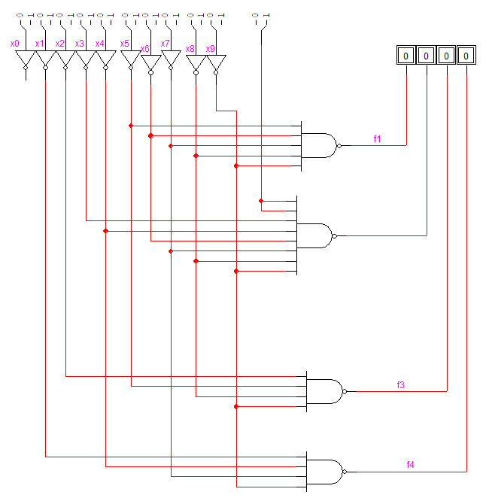

Diagrama de timp :

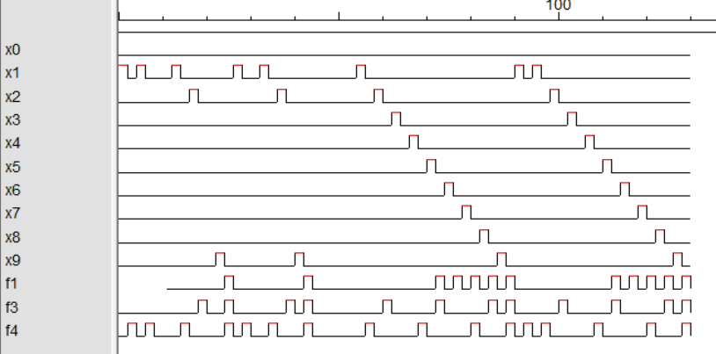

**Concluzie:**

Efectuînd lucrarea dată am făcut cunoştinţă cu sinteza decodificatorului şi codificatorului. Am aflat că tabelul de adevăr a unui decodificator complet are dimensiunile de n+m coloane şi 2n rînduri. Am mai aflat care decodificator este incomplet şi caracteristicile lui. Privitor la codificatoare se poate de spus că nu pot fi active două sau mai multe întrări concomitent.